GRADE 7 ACCELERATED · UNIT 1 · LESSON 2
Converting Between Repeating Decimals and Fractions
Teacher's Edition
Standard and Targets
MA.7.NSO.1.2 Rewrite rational numbers in different but equivalent forms including fractions, mixed numbers, repeating decimals and percentages to solve mathematical and real-world problems.
Learning target I can turn a repeating decimal into a fraction, and move between fractions, decimals and percentages.
Essential question How can you convert repeating decimals to fractions and percentages?
Building on Lesson 1, which went the other direction, and MA.6.NSO.3.5 for terminating decimals.
Working toward MA.8.NSO.1.1 — defining irrational numbers. This lesson proves every repeating decimal is a fraction; an irrational number is exactly the decimal for which this method can never work.
Where this sits in the course Second of two lessons on MA.7.NSO.1.2, which is required content of course 1205050 and which these students are meeting for the first time — they have not taken grade 7 mathematics. The code is not one the Grade 8 FAST reports, but the mathematics is: MA.8.NSO.1.1 asks students to tell a rational number from an irrational one, and the only workable definition of rational is “can be written as a fraction.” Today is where a repeating decimal stops being a curiosity and becomes a fraction, which is what makes that distinction usable.
Materials Whiteboards and markers. TI-30XA calculators. Worksheet 7A.01.02. No manipulatives needed.
Lesson at a Glance
Windy Hill periods run 53 minutes.
Segment | Slides | Time
Settle in; post the learning target | 1 | 1 min
Warm-Up: predict, then check | 2 | 4 min
Notes I–IV: why 10 helps, the four steps, choosing the multiplier, digits before the repeat | 3–6 | 12 min
Example 1: 0.666… → 2/3 | 7–9 | 5 min
Example 2: 0.363636… → 4/11 | 10–12 | 4 min
Example 3: when the repeat does not start straight away | 13–15 | 6 min
Whiteboards: 9 questions, each with its reveal | 16–33 | 16 min
IXL — start today's skills | 34 | 5 min
Total |  | 53 min

Where the lesson lives: Slides 13–15. It is the only place the mixed case is taught, and it is the case the worksheet and the Additional Practice both lean on. Cutting it leaves students applying 100x − x to everything.
This lesson runs close. Math Nation's own components total 45 to 50 minutes before any notes. The twelve minutes of notes here are not padding — the four-step outline is what students refer back to for the rest of the period, and skipping it costs more time than it saves.
No partner or group work anywhere in this lesson. Math Nation's version has four: the component titled “Collaboration” with its opening “work with your partner,” two “discuss with your partner” prompts inside it, and a Think-Pair-Share named in the teacher notes. The Collaboration is now the whiteboard sequence and worksheet questions 5 through 8; the discussion prompts are the exit ticket.
Vocabulary

repeating decimal — a decimal that never stops, but repeats a pattern forever
terminating decimal — a decimal that stops
percentage — a ratio expressed as a fraction with a denominator of 100
A note on the glossary. Math Nation lists no key terms for this lesson and four additional terms, one of which is “sample space.” That is MA.7.DP.2.1 — a grade 7 probability benchmark this course does not carry — and it appears only because one sub-question asks for the outcomes of a die roll. It is not a term for a number-sense lesson and has been dropped.
Slide-by-Slide Teaching Notes
Slide 1. Converting Repeating Decimals to Fractions 1 min
- Post the learning target.
- Frame it as the reverse trip: yesterday division took them from a fraction to a decimal, and there is no obvious way to run division backwards.
- The method they meet today is the answer, and it is the first time in the course that algebra is used to prove something rather than to find an unknown quantity.
- That framing is worth saying.
Slide 2. Warm-Up 4 min
- TYPE: Reflect, expect, check, explain.
- INDEPENDENT.
- ANSWERS: 0.444…, 0.555…, 0.888…; then 7/9 and 2/9. Almost everyone gets 2 and 3 from yesterday's pattern, and that is the point — they can already do the ninths, so today is about everything that is not a ninth. Say that when you confirm: the pattern is real and it is narrow.
- OFF THE SLIDE, YOURS TO SAY: The ninths pattern answers questions 2 and 3 in seconds. Today's method answers every other repeating decimal too.
Slide 3. Notes: I. Multiplying by 10 slides the tail without changing it 3 min
- THE NEW IDEA IN THIS LESSON, and the only one that needs believing.
- Write x = 0.666… and 10x = 6.666… one above the other on the board and point at the tails: identical, infinitely long, and therefore canceling exactly.
- Students who ask whether you can subtract infinitely many digits have asked the right question — the answer is yes, precisely because the two tails are the same.
- OFF THE SLIDE, YOURS TO SAY: That is the whole trick. Line up the tails, then subtract.
Slide 4. Notes: II. Four steps, and only step 2 changes 3 min
- Students copy all four.
- Say the panel twice — it is what makes the lesson feel small rather than large.
- There is one method here, not five, and the only decision in it is which power of 10 to use.
- OFF THE SLIDE, YOURS TO SAY: Every problem today is these four steps. Only step 2 changes.
Slide 5. Notes: III. How many digits repeat decides the multiplier 3 min
- The 9s pattern is worth naming out loud because it gives students a check on their own work: if the denominator before simplifying is not made of 9s (and possibly some 0s), something has gone wrong in step 3.
- OFF THE SLIDE, YOURS TO SAY: 9, 99, 999 — one nine for each repeating digit. That is not a coincidence.
Slide 6. Notes: IV. Digits before the repeat need a multiplier too 3 min
- Item D is the sentence students skip.
- Both multipliers have to end with the tails aligned, and when a digit sits in front of the repeat, x itself is the wrong thing to subtract.
- Example 3 is this case worked in full.
- OFF THE SLIDE, YOURS TO SAY: This is where the points go. Everything else is arithmetic.
Slide 7. Example 1 1 of the 5 min
- SPOKEN ONLY. 10x, because one digit repeats.
- Getting the decision said before the working starts is the habit that makes Example 3 survivable.
Slide 8. Example 1 2 of the 5 min
- Work it at the board, naming each step by its number from Notes II.
- Line the two decimals up vertically before subtracting so the cancellation is visible rather than asserted.
Slide 9. Example 1 2 of the 5 min
- Always check by dividing back.
- It costs ten seconds, it uses yesterday's skill, and it is the only way a student catches a slip in step 3 without being told.
- OFF THE SLIDE, YOURS TO SAY: The fraction and the decimal are the same number. Yesterday's division is how you check today's algebra.
Slide 10. Example 2 1 of the 4 min
- SPOKEN ONLY. 100x, because the block is two digits long.
- A student who says 10x has not counted the block, and 10x genuinely does not work — worth showing on the board for fifteen seconds if somebody offers it.
Slide 11. Example 2 2 of the 4 min
- Identical structure to Example 1, and say so.
- The only line that differs is the second one.
Slide 12. Example 2 1 of the 4 min
- Put the two side by side.
- The 9s pattern from Notes III is now something they have seen produced twice rather than been told, which is the difference between a check they will use and one they will not.
- OFF THE SLIDE, YOURS TO SAY: One repeating digit gave a 9 underneath. Two gave a 99.
Slide 13. Example 3 2 of the 6 min
- Take a vote before working anything.
- Most classes say yes, because 10x − x has worked twice.
- Do not resolve it.
- They are RIGHT that it works — the repeating tail is one digit long and it cancels either way — and the next slide shows what it costs them, which is a decimal they then have to clear.
- Being told is not the same as being shown.
Slide 14. Example 3 2 of the 6 min
- Do not say this fails, because it does not — the tail is a single 8 and it cancels perfectly, leaving exactly 3.5.
- Work it in front of them and let the class see they were right.
- What it does not do is land on whole numbers, and a fraction is a ratio of two INTEGERS, so 3.5/9 is not an answer.
- That is the honest reason to start one place further along, and it is the reason the denominator comes out 90 rather than 9.
- OFF THE SLIDE, YOURS TO SAY: 3.5/9 is not a ratio of two INTEGERS, so the question is not answered yet.
Slide 15. Example 3 2 of the 6 min
- The 90 underneath is the fingerprint of this case: one 9 for the repeating digit, one 0 for the digit in front.
- Check by dividing 7 by 18 and landing on 0.3888… Worksheet questions 6 and 10 are this case; question 9 is not, because its repeat starts at the decimal point.
Slide 16. Whiteboards · Question 1 of 9 — ask about 20 seconds of thinking
- Boards down until the cue, all up together, scan the back row first, and question a blank board before a wrong one.
- Do not reveal until every board is up.
Slide 17. Whiteboards · Question 1 of 9 — reveal about 1 minute with the discussion
- The baseline: one repeating digit, nothing in front.
- One 9 underneath.
- Everything after this changes exactly one thing.
- COLOR: none on this sequence. One expression and its answer is not two objects and not two slots in a formula, so under rule 5 there is no axis to name and the answer color does the whole job.
Slide 18. Whiteboards · Question 2 of 9 — ask about 20 seconds of thinking
- Boards down until the cue, all up together, scan the back row first, and question a blank board before a wrong one.
- Do not reveal until every board is up.
Slide 19. Whiteboards · Question 2 of 9 — reveal about 1 minute with the discussion
- One feature changed: the block is two digits long, so the multiplier is 100 and the denominator is 99. 45/99 simplifies to 5/11 — a board saying 45/99 has done the mathematics and not finished the question.
- COLOR: none on this sequence. One expression and its answer is not two objects and not two slots in a formula, so under rule 5 there is no axis to name and the answer color does the whole job.
Slide 20. Whiteboards · Question 3 of 9 — ask about 20 seconds of thinking
- Boards down until the cue, all up together, scan the back row first, and question a blank board before a wrong one.
- Do not reveal until every board is up.
Slide 21. Whiteboards · Question 3 of 9 — reveal about 1 minute with the discussion
- THE ONE THAT EARNS ITS PLACE.
- One feature changed: a digit now sits in front of the repeat.
- Subtracting x is not WRONG here — 100x − x gives 16.5 and 16.5/99 is still 1/6 — it just does not land on integers. 90 underneath is what does: one 9 for the repeating digit, one 0 for the digit in front.
- A board saying 16/99 has subtracted x and then dropped the .5; a board saying 15/99 has done the right subtraction and kept the wrong denominator.
- COLOR: none on this sequence. One expression and its answer is not two objects and not two slots in a formula, so under rule 5 there is no axis to name and the answer color does the whole job.
Slide 22. Whiteboards · Question 4 of 9 — ask about 20 seconds of thinking
- Boards down until the cue, all up together, scan the back row first, and question a blank board before a wrong one.
- Do not reveal until every board is up.
Slide 23. Whiteboards · Question 4 of 9 — reveal about 1 minute with the discussion
- One feature changed: a whole-number part.
- It travels unchanged, exactly as it did in yesterday's ninths. 2 + 4/9 = 22/9.
- Accept the mixed number, and ask for the improper one as well.
- COLOR: none on this sequence. One expression and its answer is not two objects and not two slots in a formula, so under rule 5 there is no axis to name and the answer color does the whole job.
Slide 24. Whiteboards · Question 5 of 9 — ask about 20 seconds of thinking
- Boards down until the cue, all up together, scan the back row first, and question a blank board before a wrong one.
- Do not reveal until every board is up.
Slide 25. Whiteboards · Question 5 of 9 — reveal about 1 minute with the discussion
- One feature changed: the repeating digit is a 9.
- The method runs exactly as in question 1 and lands on 9/9.
- Do not soften it — 0.999… IS 1, and the algebra they have just spent a lesson trusting is the proof.
- Expect resistance; the answer to 'but it never quite gets there' is that there is no 'gets there', the number is the number.
- COLOR: none on this sequence. One expression and its answer is not two objects and not two slots in a formula, so under rule 5 there is no axis to name and the answer color does the whole job.
Slide 26. Whiteboards · Question 6 of 9 — ask about 20 seconds of thinking
- Boards down until the cue, all up together, scan the back row first, and question a blank board before a wrong one.
- Do not reveal until every board is up.
Slide 27. Whiteboards · Question 6 of 9 — reveal about 1 minute with the discussion
- THE ONE THAT CLOSES IT.
- One feature changed: a zero in front.
- Same 9s block, and the answer is exactly one tenth — so 0.0999… = 0.1, with no rounding anywhere.
- If question 5 unsettled anyone, this is the one that settles it: two decimals that look different are one number, and the method says so both times.
- COLOR: none on this sequence. One expression and its answer is not two objects and not two slots in a formula, so under rule 5 there is no axis to name and the answer color does the whole job.
Slide 28. Whiteboards · Question 7 of 9 — ask about 20 seconds of thinking
- Boards down until the cue, all up together, scan the back row first, and question a blank board before a wrong one.
- Do not reveal until every board is up.
Slide 29. Whiteboards · Question 7 of 9 — reveal about 1 minute with the discussion
- One feature changed: the question is about CHOOSING the subtraction rather than carrying it out — which is what questions 1 to 3 were quietly teaching and never asked directly. 100x − x leaves 23.
- THE TWO BOARDS TO LOOK FOR, each a named error: 10x − x is question 1's habit surviving a two-digit block, and it leaves 2.0909…, not a whole number; 100x − 10x is question 3's habit arriving where nothing sits in front of the repeat, and it leaves 20.9090….
- The rule underneath is one line and worth saying: multiply so that the two lines have the SAME digits after the point, then subtract.
- COLOR: none on this sequence. One expression and its answer is not two objects and not two slots in a formula, so under rule 5 there is no axis to name and the answer color does the whole job.
Slide 30. Whiteboards · Question 8 of 9 — ask about 20 seconds of thinking
- Boards down until the cue, all up together, scan the back row first, and question a blank board before a wrong one.
- Do not reveal until every board is up.
Slide 31. Whiteboards · Question 8 of 9 — reveal about 1 minute with the discussion
- One feature changed from question 7: the block is three digits, not two. 1000x − x = 123, over 999.
- THE BOARD TO LOOK FOR SAYS 100x, and it is not carelessness — it is the student who has learned "two digits means 100" as a fact instead of as a consequence. 100x − x leaves 12.1891…, which is not whole, and that is the check that catches it before the teacher does.
- Ask what the denominator will be before anyone simplifies: 999, one 9 per repeating digit, and 123/999 is 41/333.
- COLOR: none on this sequence. One expression and its answer is not two objects and not two slots in a formula, so under rule 5 there is no axis to name and the answer color does the whole job.
Slide 32. Whiteboards · Question 9 of 9 — ask about 90 seconds of writing
- Boards down until the cue, all up together, scan the back row first, and question a blank board before a wrong one.
- Do not reveal until every board is up.
Slide 33. Whiteboards · Question 9 of 9 — reveal about 2 minutes with the closing discussion
- WRITTEN WORK, and the only question in the round that asks for it.
- With the worksheet gone this is the only place in the period the habit gets built, and IXL takes an answer without ever seeing the work.
- Question 5 gave them this answer; this asks them to ARGUE it, against an objection most of them privately hold.
- ANSWER: let x = 0.999…; then 10x = 9.999…; subtract and 9x = 9; so x = 1.
- WHAT DEVON IS DOING WRONG has a name — he is treating 0.999… as a process that is still running rather than as a number that is already there.
- There is no "gets there".
- The method they have trusted for a whole lesson says 1, and it does not get to be trusted on five questions and doubted on the sixth.
- A board that just writes "1" is right and has not answered the question that was asked.
- COLOR: none on this sequence. One expression and its answer is not two objects and not two slots in a formula, so under rule 5 there is no axis to name and the answer color does the whole job.
Slide 34. IXL 5 min
- IXL.
- The skills are assigned in Google Classroom, not named here, and they are deliberately not ours -- Croix: "The students need questions that aren't exclusively mine.
- Makes them think." Circulate.
- The thing to watch for is a student answering in the box with no paper in front of them: IXL takes an answer and never sees the work, so this is the one part of the period where the habit can quietly lapse.
Worksheet 7A.01.02 — Answer Key
1. 10x and 100x | 10x = 2.323232… 100x = 23.232323…  Multiplying by 10 moves the point one place; by 100, two places. The tail 2323… never changes.
2. which two | 100x and x  Two digits repeat, so 100x is the multiplier that lines the tails up.
3. the subtraction | 100x − x = 23.232323… − 0.232323…  99x = 23, so x = 23/99. It will not simplify: 99 = 9 × 11 and 23 is prime.
4. 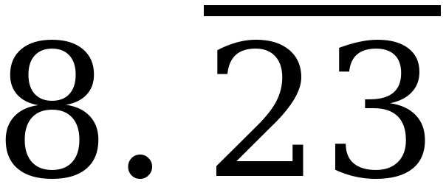 | Fraction 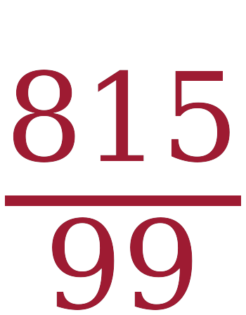 Mixed number 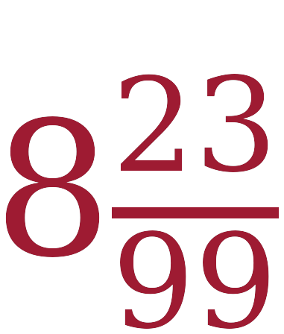  The decimal part is the 23/99 from question 3, and 8 × 99 + 23 = 815.
5. chocolate chips | 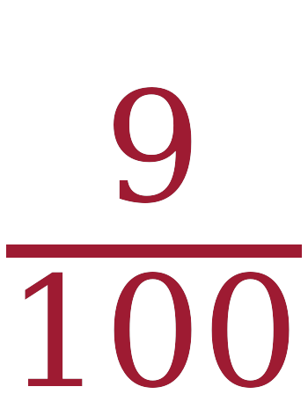  0.09 has its last digit in the hundredths place.
6. raisins |   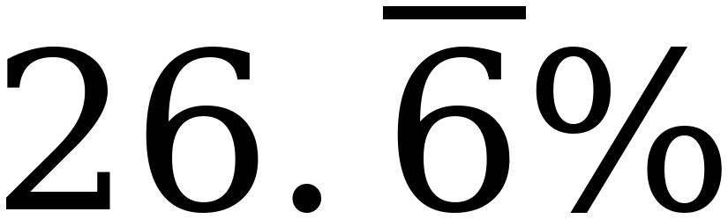 = 0.26666… The 2 does not repeat, so use 100x − 10x: 90x = 24, giving 24/90 = 4/15. This is the slides 13–15 case.
7. peanuts | 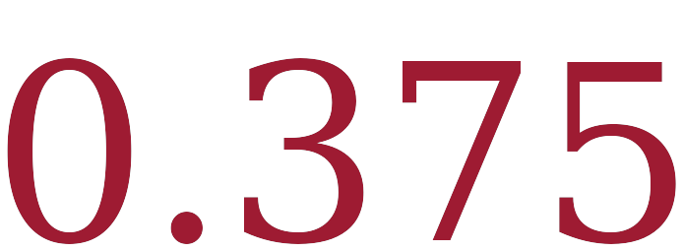  3 ÷ 8 = 0.375 exactly.
8. chex mix | About 27%  Over 600ths: 160 + 225 + 54 = 439. Then 600 − 439 = 161, and 161 ÷ 600 = 0.26833…
9. 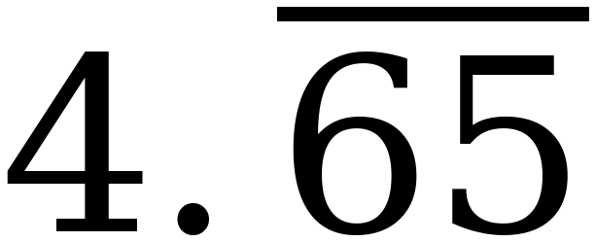 | Percent 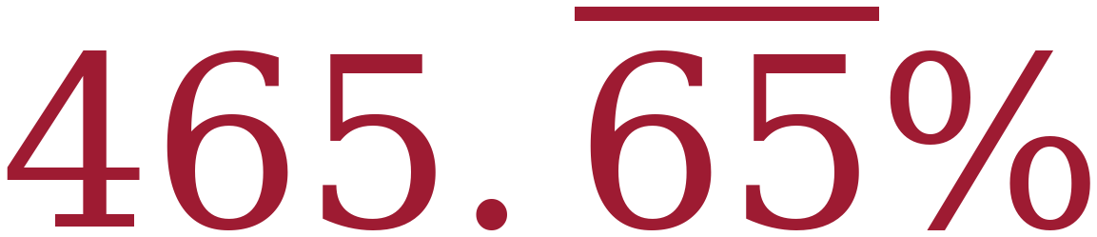 Fraction 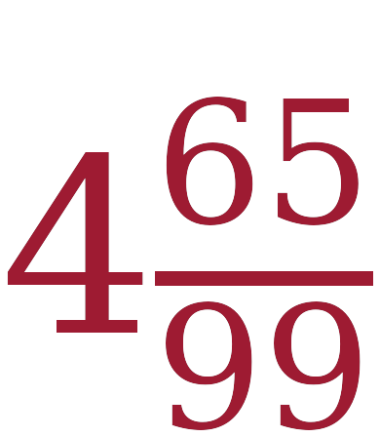  99x = 461, so x = 461/99 = 4 65/99.
10. 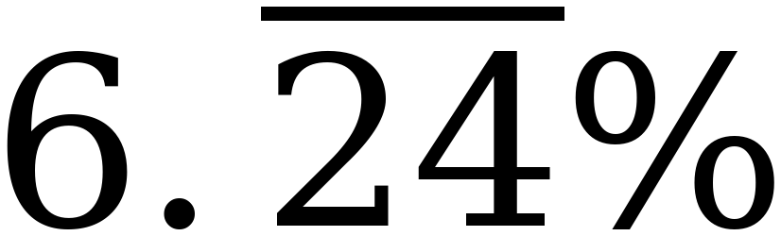 | Decimal 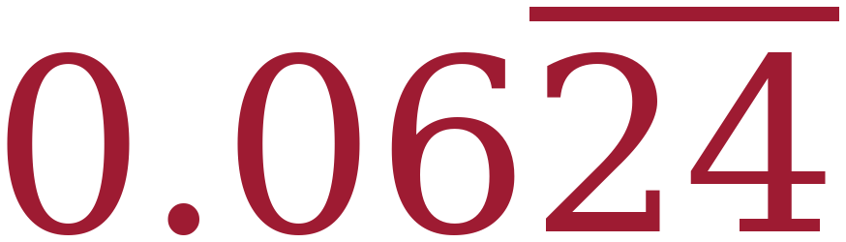 Fraction 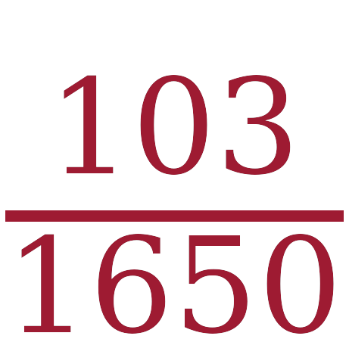  100x − x on 6.242424… gives 99x = 618, so 6.242424… = 618/99 = 206/33. A percent is out of 100, so divide by 100 at the end: 206/3300 = 103/1650.

Questions 6 and 10 are the two to circulate for. Both are percents whose decimal form has a digit in front of the repeat, so neither yields to a plain 100x − x: question 6 needs 100x − 10x on 0.26666…, and question 10 clears the repeat on 6.242424… with 100x − x and then divides by 100. Both are slides 13–15 — question 6 inside a word problem, question 10 as a row of the conversion table.
Question 8 has two honest routes. Common denominators over 600ths is the exact one. Adding 0.26666… + 0.375 + 0.09 on a calculator and subtracting from 1 is faster and gets the same 27%. Both earn the point; the question says “about” and asks for the nearest whole percent.
Question 10 is deliberately ugly. 103/1650 is what the mathematics gives. For an accelerated class the tedium is not the difficulty — the two-stage conversion is. Mark the method, not the arithmetic.
Additional Practice 7A.01.02 — Answer Key
Post this in Google Classroom alongside the practice sheet. It is optional work for students who want more.
1. 10x and 100x | 10x = 5.888… 100x = 58.888…
2. which two | 100x and 10x  The 5 does not repeat, so x on its own is no help.
3. the subtraction | 100x − 10x = 58.888… − 5.888…  90x = 53, so x = 53/90. 53 is prime.
4. 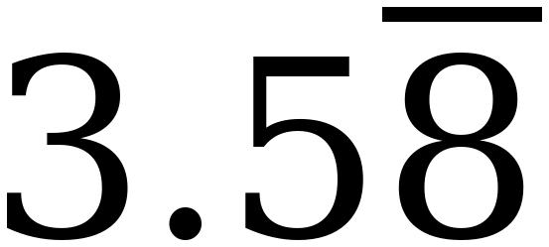 | Fraction 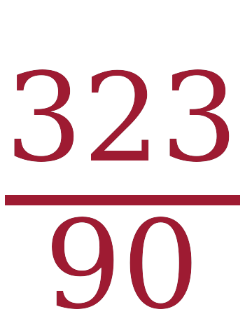 Mixed number 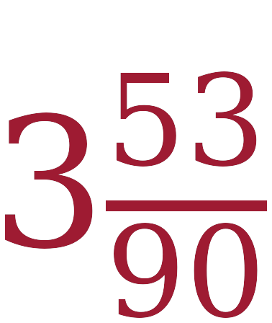  3 × 90 + 53 = 323.
5. chocolate chips |   0.14 = 14/100 = 7/50.
6. raisins | 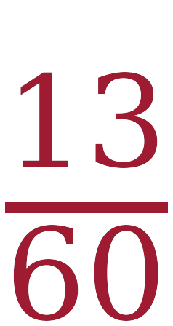  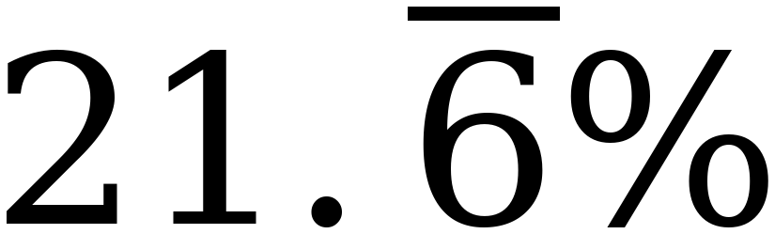 = 0.21666… Two digits in front of the repeat, so 1000x − 100x: 900x = 195, and x = 195/900 = 13/60.
7. peanuts |   5 ÷ 9 = 0.5555… The bar is required.
8. chex mix | About 9%  Over 900ths: 195 + 500 + 126 = 821. Then 900 − 821 = 79, and 79 ÷ 900 = 0.0877…
9. 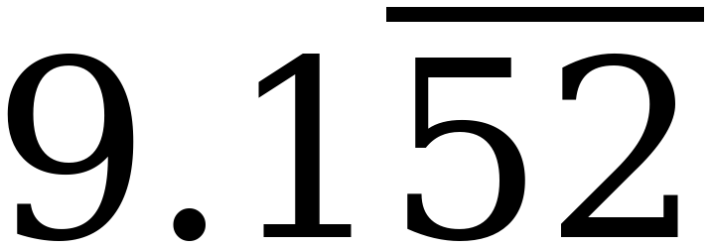 | Percent  Fraction 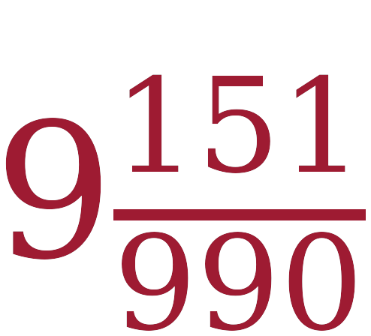  One digit does not repeat, so use 1000x − 10x: 990x = 9061.
10.  | Decimal 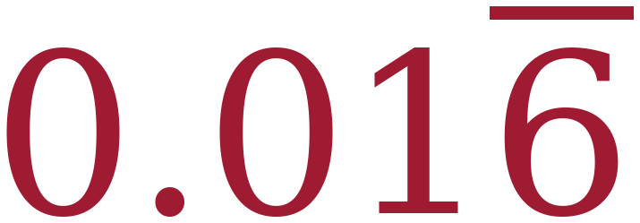 Fraction   Divide by 100 first: 1.666…% = 0.01666… Two digits in front of the repeat, so 900x = 15 and x = 1/60.
Misconceptions to Watch
- Mixing up the order when dividing numerator and denominator. Named in Math Nation's list for this lesson. (Math Nation TE)
- Not knowing which equations to use to eliminate the repeating pattern. Also named in their list, and it is the reason Notes III and slides 13–15 exist. (Math Nation TE)
- Forgetting the bar. Named in their list for the second lesson running. (Math Nation TE)
- Not distinguishing terminating, repeating and rounded decimals. Lesson 1's Example 3 is built on it. 0.555555556 on a screen is a rounded calculator display, not a terminating decimal. (Florida B1G-M)
- Truncating a repeating decimal. Writing 0.232323… as 0.23 and calling it done. (Florida B1G-M)
- Applying 100x − x to every problem. It always cancels the tail, but it lands on whole numbers only when the repeat starts at the decimal point; otherwise it leaves a decimal that still has to be cleared. Slides 13–15.
- Leaving the fraction unsimplified. 36/99 is correct arithmetic and an incomplete answer.
- Forgetting to divide a percent by 100. Worksheet questions 6 and 10 both catch this.
Changes from the Math Nation Lesson
- Every partner and group activity is replaced. There were four: the component titled “Collaboration” with its opening “work with your partner,” two “discuss with your partner” prompts inside it, and a Think-Pair-Share named in the teacher notes for question 2b.
- A missing bar was added. Math Nation's Aliyah problem reads “There is a 33.3% chance of winning the game on any roll” and expects the answer 1/3 — but 33.3% is 333/1000. It now reads 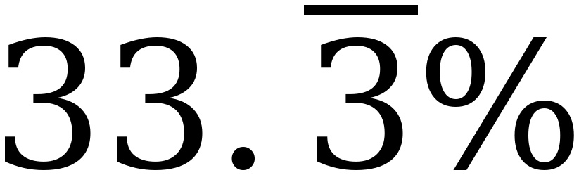. This matters more than a typo normally would, because the question directly above it teaches that 22% is wrong precisely because the exact value repeats.
- The Skittles problem was made internally consistent. As printed, 21% of the package is red and part c says there are 60 Skittles — but 21% of 60 is 12.6 Skittles. Red is now 25%, which gives 15 of 60, and every count in the problem is a whole number. Part a still tests percent-to-fraction.
- The Uno answer now leads with 2/9. Math Nation gives 6/27, which is equivalent but not in lowest terms. Both are accepted, per Florida's rule against demanding simplest form as the only answer, but the key leads with the simplified value.
- Worksheet question 3 was rebuilt. As printed the answer space was a floating drawing of two empty dashed rectangles rather than text — it moved on the page and printed as boxes. It is now a written subtraction step with room to work.
- The Additional Practice raisin value was retuned from 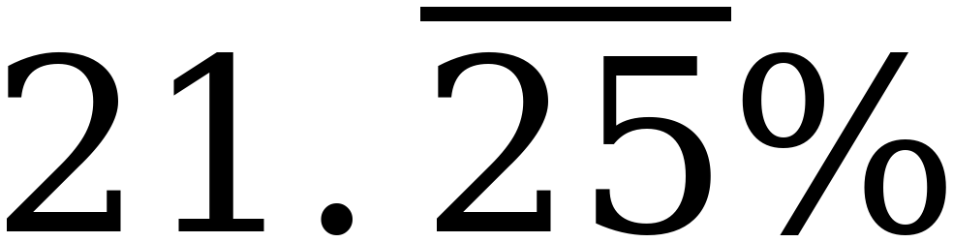 to . The published value gives 2104/9900 = 526/2475, an answer no student can check. The new value keeps the same structure — non-repeating digits in front of a repeating block — and gives 13/60, which a student can check by dividing. The chex mix total is still 9%.
- The Additional Practice stem “5.3636..” had a two-dot ellipsis. Corrected.
- “Sample space” was removed from the vocabulary list. It is a probability term from a benchmark this course does not carry, and it appeared only because one sub-question mentioned a die.
- The Wrap-Up was replaced. Math Nation's is a four-row conversion table with no reasoning asked for. The Ticket Out the Door asks for three conversions instead, chosen so that each needs a different multiplier — 0.555…, 0.272727… and 0.1444… — which is what predicts who is ready for tomorrow.
- A full slide was added for the case where the repeating part does not start at the decimal point, and the Additional Practice was built entirely on that case so the two sheets are not interchangeable.
- Answer keys were built for both sheets, from the same source file as the student versions, so the two cannot drift apart.
- Nothing in the mathematics was changed apart from the two corrections and the one retune noted above.

